Media credits list
Apps for Enquiry 1 Great Fire of Tyneside

Shopping task: 10 items for sale in the Quayside shop, some essential others nonessential
DESCRIPTION | THUMBNAIL | CREDITS
bread | 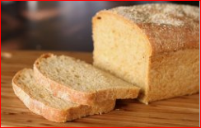 | https://en.wikipedia.org/wiki/List_of_American_breads#/media/File:Anadama_bread_(1).jpg CCBY
juice | 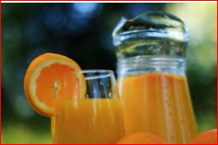 | http://www.pexels.com/photo/healthy-breakfast-orange-juice-health-3603/ CC0
apples | 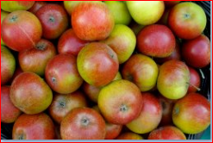 | https://www.flickr.com/photos/wheatfields/3026556399 CCBY
bandage |  | https://commons.wikimedia.org/wiki/File:Adhesive_bandage_drawing_nevit.svg CCA SA
teddy bear | 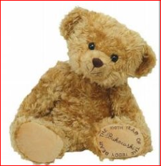 | https://commons.wikimedia.org/wiki/File:Newer_teddy_bear.jpg public domain
sweets | 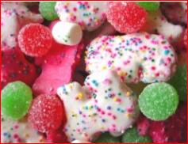 | https://www.flickr.com/photos/patrick_q/94535514 CC BY-NC
book | 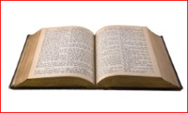 | https://pixabay.com/en/book-books-old-old-books-read-97709/ CC0
baked beans | 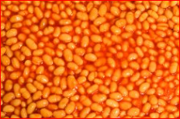 | https://www.flickr.com/photos/79017140@N08/16510729572 CCBY
cheese | 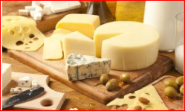 | https://www.flickr.com/photos/68711844@N07/15638541227 CCBYSA
blanket | 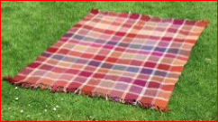 | https://www.flickr.com/photos/theowright/755393535  CC BY-NC-ND

Sorting: 10 building materials, not all suitable to build a new factory
DESCRIPTION | THUMBNAIL | CREDITS
bricks | 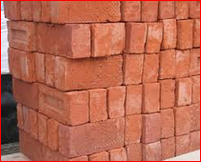 | https://en.wikipedia.org/wiki/Building_material#/media/File:Stapel_bakstenen_-_Pile_of_bricks_2005_Fruggo.jpg CCBY
wood | 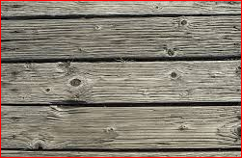 | https://pixabay.com/en/wood-boards-old-grain-383702/ CC0
bamboo | 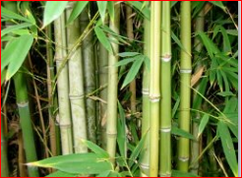 | https://commons.wikimedia.org/wiki/File:Bamboo_Forest.jpg CC Attribution
straw | 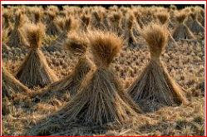 | https://commons.wikimedia.org/wiki/File:Straw_of_the_rice.08Oct9.jpg public domain
corrugated iron | 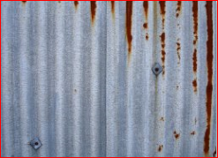 | https://www.flickr.com/photos/wheatfields/405740857  CC BY-NC-SA
corrugated plastic (fibreglass) | 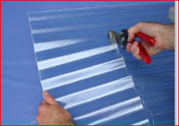 | https://www.flickr.com/photos/vox/366660083 CC BY-NC-ND
fabric | 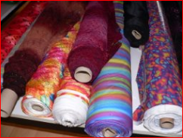 | https://en.wikipedia.org/wiki/Bolt_(fabric)#/media/File:Stoffballen2_fcm.jpg CC BY SA
sponge | 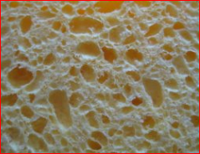 | https://commons.wikimedia.org/wiki/File:Cleaning_sponge_detail.jpg CC BY SA
glass | 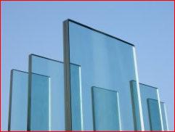 | https://www.flickr.com/photos/fabi42/270683309 CC BY-NC-SA
cardboard | 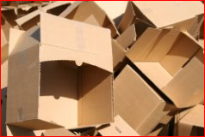 | https://www.flickr.com/photos/28458676@N00/3630632170 CC BY-NC

